Revolution & the Seasons

Original impressionistic (hand-drawn) charts: purchase here
Purchase the MFE charts here.

Prerequisite: Perpendicular and Oblique rays (find lesson here)

MATERIALS:
Foam ball (large)
Knitting needle
Light bulb
Elliptical cut-out (or chalk outline on floor)
Yellow cut-out to fit foam ball
Charts (see lesson below)

Pre-requisite activity: Identify north/east/south/west in your home and place labels on the walls.

PRESENTATION A: Revolution and the seasons

- Pierce a foam ball with a knitting needle. Light the light bulb and rotate the needle on its own axis and also around the Sun (light bulb). COUNTER-CLOCKWISE!

- Explain that the needle is the axis. The Earth is tilted, it is inclined on an angle. When the Earth moves around the Sun, because of this tilt, all parts of the Earth facing the sun do not feel the same heat.

- Place a large elliptical paper cut-out under the Sun or use chalk or dry-erase marker to draw the ellipse. This is the path the Earth takes around the sun. We call it an orbit. It is not circular.

- Place the globe on the edge of the ellipse, with the narrow end of the ellipse pointing towards the North Star (the “north” label on your wall). Turn the globe on its axis (stationary) to see how the light hits it. Then, move it one-fourth of the way down the ellipse to show how the light hits mostly on the Northern Hemisphere. Do not spin it. Move it again one-fourth of the way to show how the light is being distributed. Move it one more time, one-fourth of the way, to show how this time more light is hitting the Southern Hemisphere.

- Note: When we move the globe around the sun, make sure that the North Pole always faces the same direction. You should have the North Star posted up on a wall and the North Pole should always face the North Star.

- When the North Pole is coming into the light, we have Spring. Then the Earth continues its orbit and the North Pole is tilted towards the light. We have Summer. Continue the orbit to show the N.P. is leaving the light, we have Autumn. Keep following the orbit so that very little light hits the NP. We have Winter. Finish the orbit by returning to Spring.

- In Spring, the rays of the sun fall perpendicular to the Equator. In the Summer, the rays fall perpendicular to the Tropic of Cancer. In the Fall, the perpendicular rays strike the Equator. In the Winter, the perpendicular rays hit the Tropic of Capricorn.

- Cut a piece of yellow construction paper to wrap around half the circumference of the globe, and draw a red line down the middle (at the Equator). Fit it from Pole to Pole to show how the rays come perpendicularly.

- Put the globe in Spring position. We have the Spring Equinox. Equinox comes from Latin: nox = night and equi = the same.

- Move the globe to Summer. We have the Summer Solstice. From Latin Sol = sun and sistere = standing still. This is when the day is the longest and the night is the shortest.

- Move the globe to Autumn. We have Autumn Equinox. Day and night are the same length.

- Move the globe to Winter. We have Winter Solstice. It is the shortest day and longest night of the year. Then the days start to be come longer until we reach the Spring Equinox.

- Do this a couple of times with the children to review the terminology, perhaps adding a little more information the second time around. You can also invite the children to have a turn making the orbit around the Sun, perhaps giving them a point of reference and letting them compare the Northern and Southern hemispheres. This depends on how much information the children have grasped.

Follow-up Activity: Cut up a calendar into the four seasons and guide the children in an exploration of the months of the year and what season each one falls in, including the equinoxes and solstices. Use the dates for these special dates (you can wait to use the dates if you haven’t introduced them yet).

PRESENTATION B: The importance of tilt

- Show chart 15a. It shows the Earth moving in its orbit around the Sun.
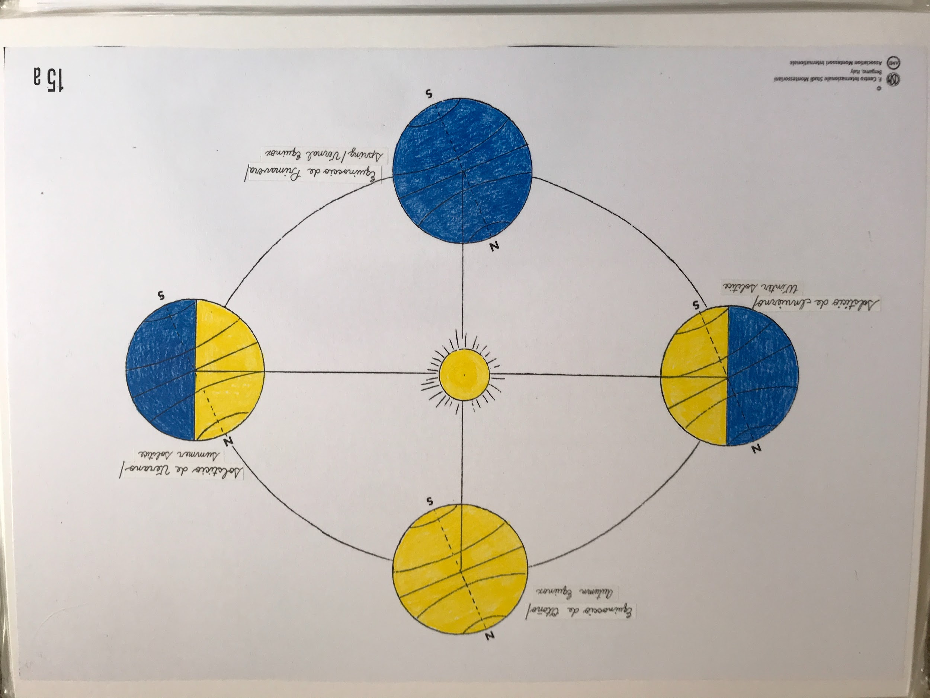
- Point out the line that goes from the Sun to the Earth in the Spring image. Then point out how in the Summer the Northern Hemisphere is tilted towards the Sun. The rays of the sun strike perpendicularly on the Tropic of Cancer. Continue tracing the orbit with your finger, and show how in the Autumn the sun’s rays strike perpendicularly on the Equator. Then the Pole is tilting away from the sun, and the rays of the sun are striking perpendicularly on the Tropic of Capricorn.

Note: You can have the months of the year cut up so the children can do the work of determining which months fall into each season.

- Show chart 16a
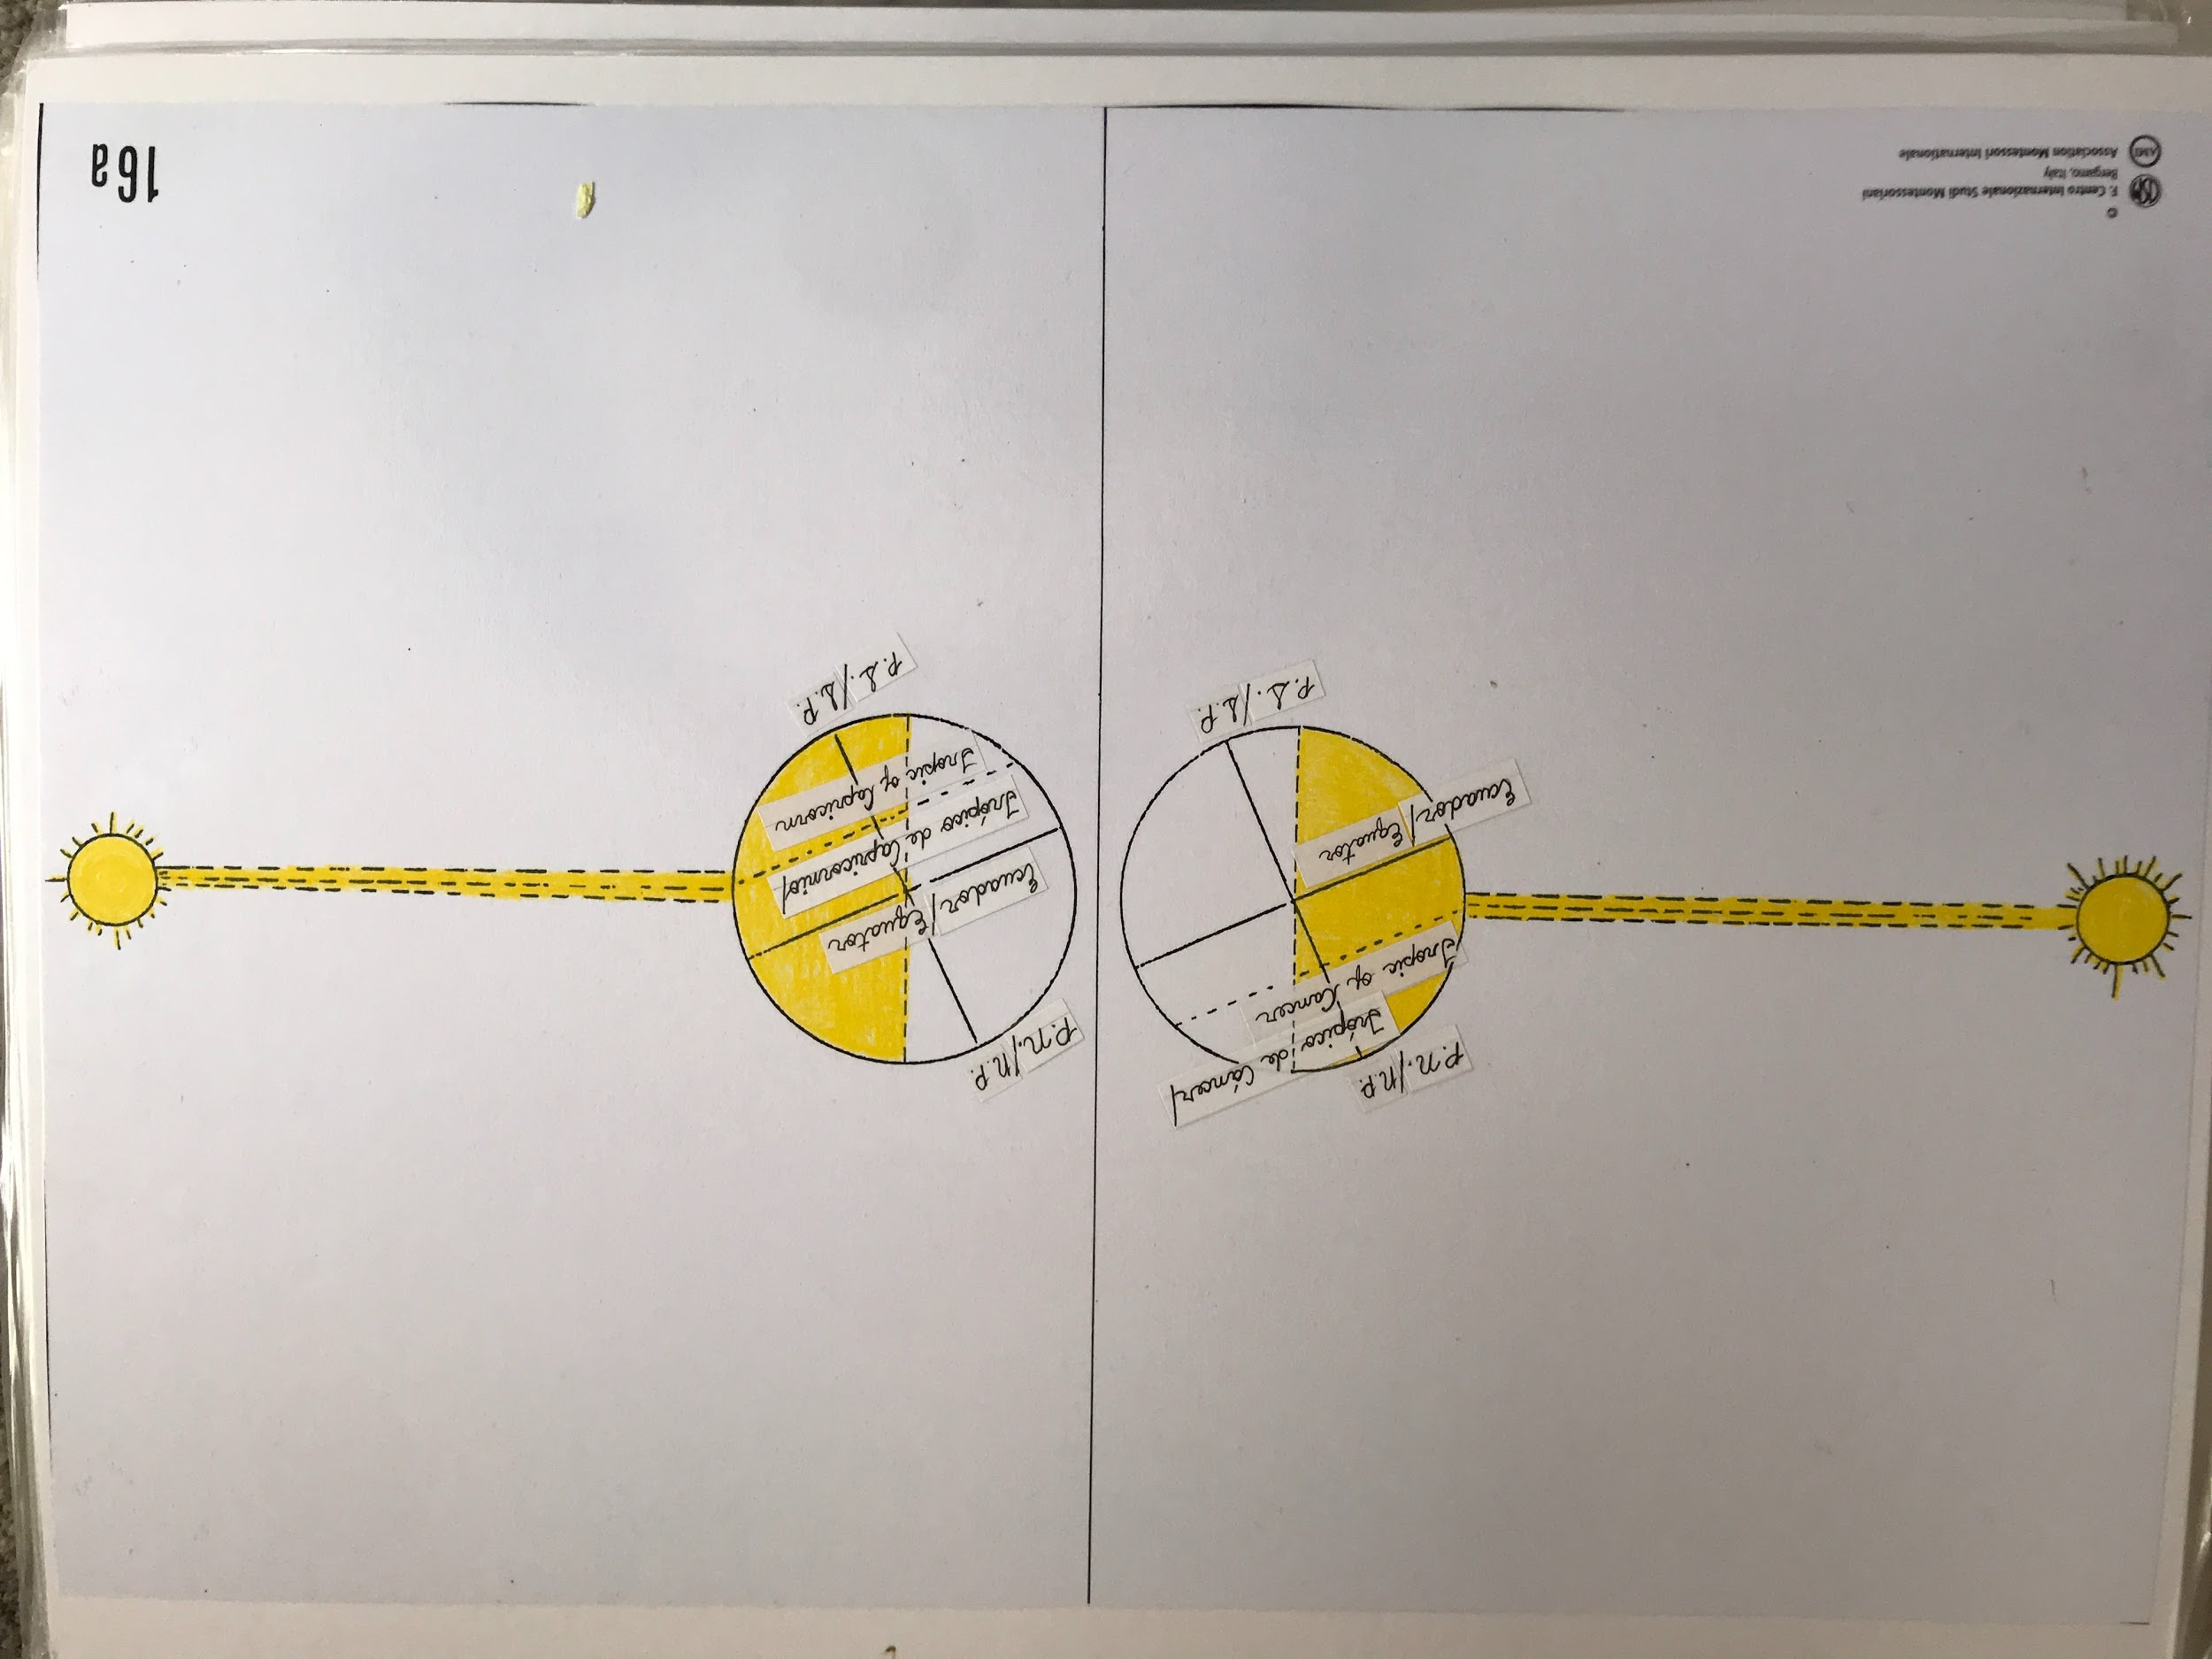
- We are focusing on latitudes at this point. It shows when the sun’s rays hit perpendicularly, and what part is in Summer/Winter depending on which way the Earth is tilting.

Note: For older children who have an understanding of angles and degrees:
- Take out the special measuring angle: right angle with blue legs and a red hypotenuse.
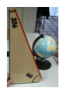

- Once they have understood the tilt of the Earth, you can show them the angle.

- Rest the angle on the short leg and lean it against the globe to show the tilt of the Earth’s axis (23.5°). Then turn it on the long leg to show how the Equator tilts (66.5°).

